**St. William Hand Bell Choir**

Ron Casler Carol Johnson

MJ Choate Ann Mallon

Mary Hammill Carol O’Halloran

Clara Henderson Lois Richter Penny Hennessy Pam Schueneman

Bill Schueneman

**St. William Choir**

**Sopranos Altos**

Betty Davis Barbara Lyon

Clara Henderson Marjorie Mathieu

Marge Kelso Jeanne Earle McConnell

Lucy Loehle Pam Schueneman

Mary Lynch *Linda Ashford

Leslie Mattingly **Tenors**

Peg Meegan Steve Bristol

**Lee Norvell Mark Shafer

Kathy Snell Mark Valentine

Judith Spanos *Christopher Soule

**Basses**

Greg Henderson

Donald Kearns Bill Schueneman

\***Jekyll Singers**

**Director: Kate Hamer**

**Accompanist: Lois Richter**

**\*\*Accompanist: Lee Norvell**

CROSS20

**Service**

**OF**

**Shadows**

**A Lenten Concert and**

**Tenebrae Service**

**7:30 pm**

**Sunday, April 6, 2025**

**St. William Catholic Church**

**Presented by**

**St. William Choir and Hand Bell Choir**

**A Choral Tenebrae:**

Meditation on the Passion of Jesus

*This Service of Shadows draws our attention to elements of human nature and human weakness which caused the betrayal, denial, conviction and crucifixion of Christ.*

**Welcome and Gathering Hymn**

**Beyond the Days #131**

**Hand Bell Choir**

***Rigaudon*** *Louis-Claude Daquin*

*Arr. Hermonet*

***Ah, Holy Jesus / Nine Tailors***

*(Variations on Chorale by Johann Cruger)*

*Arr. Paul J.Sticha*

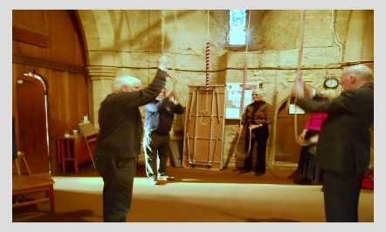

**The Choir**

***Face the Cross***

*Ruth**Elaine Schram and Scott Schram*

**A Service of Shadows** *Lani Smith*

***Introduction:*** ***Fr. Emmanuel Antwi***

**6.** **The Crucifixion** (Luke 23: 32-46)

CRUCFIX3 *Fr. Emmanuel Antwi*

**VI. Christ Crucified**

No more the heat, no more the nagging thirst,

No more the taunts of jeering mob,

No more the scathing stings of whip or club,

No more the vicious racking pain,

The vicious racking pain of nails and cross.

Only loneliness remains;

He takes it through the door of death unwillingly, but with a depth of understanding only He could know. He lived for us, He died for us, and now He knows the loneliness of His death was no greater than the loneliness of His life.

**DARKNESS…..**

A moment of reflection

**Prayer and Dismissal**

**Fr. Emmanuel Antwi**

**5.** **The Trial** (Mark 15: 1-15)

*Kim Hanley*

**V. Jesus Before the People**

*Soloist:* *Mark Shafer*

See Him as He stands before the people. See the patient suffering in His bruised and battered face.

See how He stands in utter silence. He answers not; He breathes not a word.

Hear the accusations of the chief priests. Hear the vicious slander from those vain and jealous men. Yet He betrays no hint of anger. He answers not; He breathes not a word.

JESUS7Hear the words of Pilate as he speaks to the people:

“*I find this man not guilty.*

*Shall I set him free?”*

**“Give us Barrabas!**

**Give us Barrabas!”**

“*What then should I do*

*to this king of the Jews?”*

**“Crucify Him! Crucify Him!”**

*“But what has he done? Of what crime*

*is he guilty?”*

**“Crucify Him! Crucify Him!**

**Crucify Him!”**

O Lord, it appears that we have forsaken you!

I pray, O God, that it not, be

**1. The Betrayal** (Matthew 26:17-25)

*Marion Cherne*

**I. Who Will Betray the Son of God?**

Who will betray the Son of God?

Who will deliver the Lord to death?

Who will be the one who must bear the awful curse?

Who will it be? O God who will it be?

Who will the pawn of Satan be?

Who will be traitor to Christ the Lord?

Who will sell his soul for the life of God’s own Son?

JESUS1 Who will it be? O God who will it be?

Who will bring the kiss of death to Christ?

Who will give the Savior to sinful man?

Who will send the Lord on his road of

pain and shame?

I pray, O God, that it not, be me.

**2.** **The Agony** (Matthew 26: 36-46)

*Beth Boone*

**II. Could You Not Watch with Me One Hour?**

*Soloist: Steve Bristol*

*“Could you not watch with me one hour?”*

How strange to hear such words from such a man;

A man so self-sufficient, so strong of mind and soul! What need has He for solace of companionship?

“*Could you not watch with me one hour?*

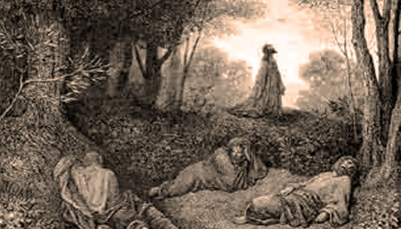

Once more He cries aloud His anguished plea.

That all that lies before Him may not be His to bear.

But yet He takes the cup and drinks it willingly.

*Could you not watch with me one hour?”*

The time has come, and all His prayers are done.

He meets the task with courage,

but somehow, He has changed.

Perhaps He’s learned the loneliness, of Saviorhood.

**3.** **The Arrest** (Luke 22: 47-53)

*Kathleen Durham*

**III. After the Arrest in the Garden**

The incident is over, and peace rules the garden again.

The normal sounds of night have banished every trace of shouted curse.

The scuffling mob has long since gone and the disciples have fled in fear.

Most who were here will soon forget this night.

 But a certain slave,

Touches his ear,

touches his ear,

In wonder mixed with gratitude,

And he will not,

he will not soon forget.

**4.The Denial** (Luke 22: 54-62)

*Sam Choate*

**IV. The Defense of Simon Peter**

MCj03190920000[1]

They asked me if I knew Him; what else could I say?

For if I said I knew Him, they’d kill me right away.

And how then could I save Him, body rent from soul?

Denial was my pretext; His rescue was my goal.

But after I denied Him time and time again,

My eyes began to open.

I saw how wrong I’d been.

It wasn’t for His rescue that I claimed him not.

The reason for my action was

fear of what men thought.

But judge me not too harshly if my ways seem grim; How often has the cock crowed, since you first learned of Him?