Nineteenth Sunday in Ordinary Time
August 11, 2024
Year B
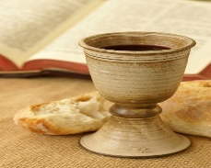
This Photo by Unknown Author is licensed under CC BY-NC-SA

Prelude: Serenity Prayer

Cantor: Let us sing together:

Gathering Table of Plenty (MI 312)

Gloria Mass of Resurrection

Responsorial Psalm R&A

Gospel Acclamation Joncas Alleluia
Vs. I am the living bread that came down from Heaven;
Whoever eats this bread will live forever.

Cantor: As we present our gifts to the Lord, let us sing:
Presentation of Gifts Spirit and Grace (MI 362)

Holy,Holy,Holy Mass of Resurrection
Memorial Acc.
Great Amen
Lamb of God

Cantor: Let us sing:
Communion One Love Released (MI 333)
Taste and See (Kendzia, MI 337)

Cantor: Let us joyfully sing:
Sending Blest Be the Lord (MI 448)

