January | 2018
Monday | Tuesday | Wednesday | Thursday | Friday | Saturday | Sunday
1 | 2 | 3 | 4 | 5 | 6 | 7
 |  | No Rehearsal | No Rehearsal |  | Kay 5:30 | Marjorie 8:00  Kay 10:30
8 | 9 | 10 | 11 | 12 | 13 | 14
 |  | Choir 7:00 | Hand Bells 7:00 |  | Lucy 5:30 | Michael 8/10:30
15 | 16 | 17 | 18 | 19 | 20 | 21
 |  | Choir 7:00 | Hand Bells 7:00 |  | Johnathen  5:30 | Johnathen  8/10:30
22 | 23 | 24 | 25 | 26 | 27 | 28
 |  | Choir 7:00 | Hand Bells 7:00 |  | Marjorie 5:30 | Steve 8:00 /10:30
29 | 30 | 31
 |  | Choir 7:00
Events | EPIPHANY: January 6th and 7th  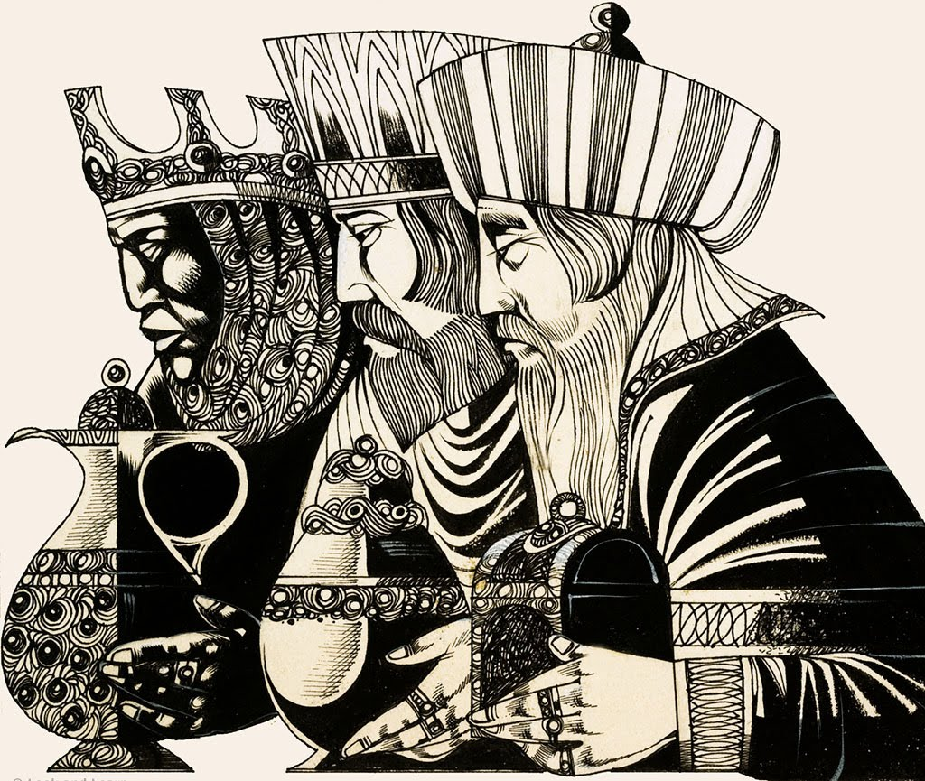  This Photo by Unknown Author is licensed under CC BY-NC-SA | JANUARY 7, 1978  Jean Kathleen Wade  and David Rashid Hamer  were married at  St. Sebastian’s Church  In Akron, Ohio | HAPPY 40Th Anniversary!

