Twenty-Fourth Sunday in Ordinary Time
September 16, 2007
Year C
Teen Mass
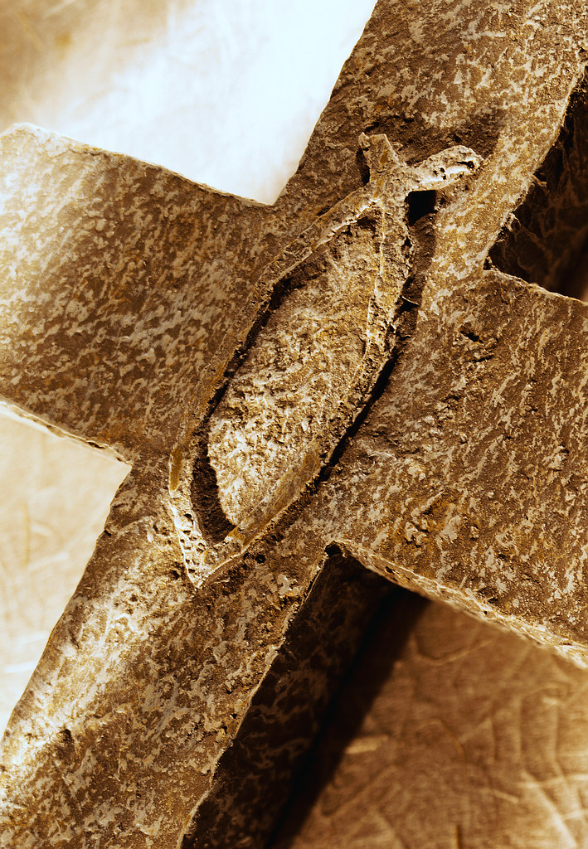
Cantor: Please stand, and join in our gathering hymn:

Gathering Blest Be the Lord (MI 447)

Gloria Celtic

Responsorial Psalm R/A

Gospel Acclamation Kate’s Alleluia
Vs. God was reconciling the world to himself in Christ
And entrusting to us the message of reconciliation.

Cantor: As we present our gifts to the Lord, please join in singing:
Preparation of Gifts: Instrumental

Holy,Holy,Holy Celtic
Memorial Acc. Celtic
Great Amen Celtic
Lamb of God Celtic

Cantor: Please join in singing our communion song:

Communion One Bread, One Body (MI 348)

Cantor: Please join in singing our sending song:
Sending Peace is Flowing (MI 485)

